

Project:

PayPal

Student Name:

منصور سلطان القحطاني

Student Number:

441051297

Supervised by:

د. محمد سعد عسيري

1. Feasibility Study & Project Proposal:

A. Introduction:

When it comes to online payments, security is a significant concern. Fraud activities and cyber threats are always a risk, making it essential to choose the right payment method. PayPal is often recommended as one of the safest options available for making digital transactions. PayPal has a reputation for security, protecting the interests of both merchants and customers. By linking their bank account or credit card information, users can easily send and receive money through PayPal's platform. They can even take advantage of services like PayPal Credit which provides interest-free payment or PayPal Here that allows small businesses to accept credit card payments in person.

B. Problems:

Before the creation of PayPal, there were several issues with online payments that made people hesitant to use them. One of the main problems was the lack of trust between buyers and sellers. People were worried about fraud and theft, and Traditional payment methods like checks and wire transfers were slow and inconvenient.

C. Background:

PayPal is an online payment system founded in 1998. It allows individuals and businesses to send and receive money electronically. Users can link their bank accounts, credit cards, and debit cards to their PayPal accounts. PayPal charges a fee for certain transactions and has become a popular payment method for online transactions. It has also expanded into other areas such as peer-to-peer payments through Venmo and in-store payments through partnerships with retailers.

D. Proposed Solution:

PayPal was created to solve these problems by providing a secure and convenient way for people to make online payments. Users can link their credit or debit cards to their accounts, which simplifies the payment process and reduces the risk of fraud. PayPal also offers buyer-seller protection policies that help to build trust between parties. If a buyer does not receive their item, or if it is significantly different from what was described, PayPal will refund the purchase price. Similarly, if a seller ships an item but does not receive payment, PayPal will cover the loss. Overall, PayPal has revolutionized the online payment industry by providing a fast, secure, and convenient way for people to make transactions.

E. Work Plan:

|  |  |  |  |
| --- | --- | --- | --- |
| Task | Start | End | Days |
| Introduction | 10/5 | 12/5 | 2 |
| Problems | 12/5 | 15/5 | 3 |
| Background | 16/5 | 17/5 | 1 |
| Proposed solution | 13/5 | 16/5 | 3 |
| Work plan | 10/5 | 30/5 | 20 |
| Functional requirements | 17/5 | 19/5 | 2 |
| Non-functional requirements | 18/5 | 20/5 | 2 |
| Activity diagram | 20/5 | 22/5 | 2 |
| Project use case modeling | 22/5 | 24/5 | 2 |
| Sequence diagrams | 24/5 | 26/5 | 2 |
| Class diagram | 26/5 | 27/5 | 1 |
| Presentation slides | 28/5 | 30/5 | 2 |
| Report | 10/5 | 30/5 | 20 |

2. Project Requirements:

A. Functional Requirements:

1. sign in:

A customer to be able to use this system shall enter a username and password which were created before and have been saved in the database on the sign-up page.

2. Profile editing:

Users should be able to edit their profile information at any time, including their name, email address, physical address, and payment preferences.

3. Payment Request:

The system shall allow users to request payments from other PayPal users through email or other communication channels. It should also provide options for customizing payment request templates.

4. Payment option:

PayPal offers a variety of payment options to users, including credit and debit cards, bank transfers, and PayPal balances. Users shall have the option to choose which payment method they prefer and can easily switch between payment methods as needed.

5. Send payment:

The customer shall be logged into PayPal System to be able to make their transaction for transfer funds.

6. Pay bills:

The customer shall be logged into PayPal System to be able to pay their bills. .

7. Payment activity:

PayPal shall provide detailed reporting and analytics tools that allow users to track their payment activity, view transaction histories, and generate customized reports.

8. Sign out:

A customer shall have the option to sign out after being signed in.

B. Non-functional Requirements:

1. Security:

PayPal shall ensure that its payment processing system is secure and protected against unauthorized access or malicious attacks. This includes implementing security measures such as encryption, two-factor authentication, and fraud detection algorithms.

2. Performance:

PayPal shall provide fast and reliable payment processing services to users, with minimal downtime or delays. This includes optimizing system performance, scalability, and availability to handle large volumes of transactions.

3. Usability:

PayPal shall provide a user-friendly and intuitive interface for users to make and receive payments, manage their accounts, and access support and resources. This includes designing the payment flow and user interface to be simple, clear, and easy to navigate.

4. Compatibility:

PayPal shall be compatible with a wide range of devices and platforms, including desktop and mobile devices, web browsers, and operating systems. This includes ensuring that PayPal works seamlessly with popular e-commerce platforms and shopping carts.

3. Activity Diagram:

4. use case modelling:

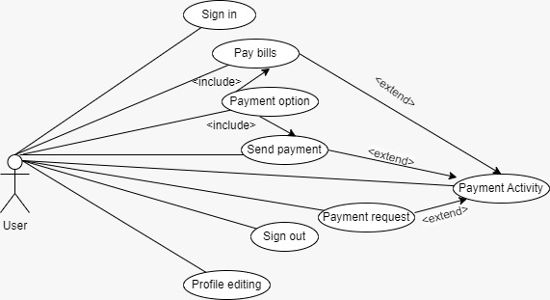

5. Sequence diagram:

6. Class diagram:

